Iddle
international Symposium on Adhesive and Digital Restorative Dentistry
July 18- 19, 2020
University of Washington, Seattle, WA, USA
Following the successful hosting of IAD 2019 (https://iad2019.com/), the department has decided to hold a similar program in 2020. The program outline as of Dec 2019 is as follows:
Place: Conference Hall, University of Washington, 1959 NE Pacific St, Seattle, WA, 98195
Organizer: Department of Restorative Dentistry, UW
Audience: International participants, opinion leaders and local practitioners (capacity: 200)
Speakers as of Dec 2019
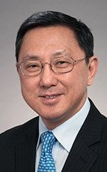 | Prof. Daniel Chan  Chair, Restorative Dentistry, UW | 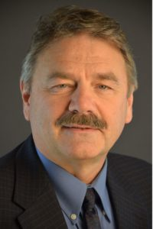 | Prof. John Sorensen  Director of Research, Restorative Dentistry, UW
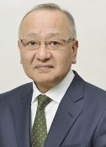 | Prof. Junji Tagami  Chair, Cariology and Operative Dentistry, TMDU (Japan) | 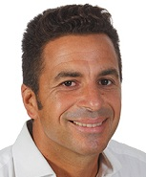 | Dr. Riccardo Ammannato  Studio Dentistico, Genoa, Italy  (conditionally agreed)
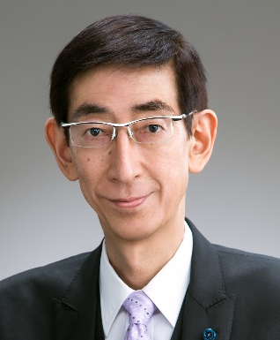 | Prof. Hidehiko Sano  Chair, Operative Dentistry Hokkaido University (Japan) | 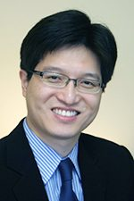 | Dr. Yen-Wei Chen  Restorative Dentistry, UW
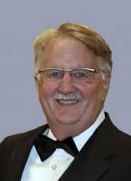 | Dr. Grant Chyz  Private Practice, Seattle, WA  (conditionally agreed) | 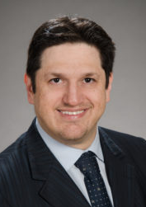 | Dr. Alireza Sadr  Restorative Dentistry, UW

Sponsorship Packages:
Currently, the following sponsorship levels are available, we are also open to your proposals for sponsorship, including in exchange of support for international speaker.
- Purple-level: $15,000: inclusion of logo on all event materials, banner at the stage, opportunity to sponsor an additional 45-min presentation at the event by a recommended speaker, exhibition desk, 15-min corporate presentation, acknowledgement at podium and dinner
- Gold-level: $10,000: inclusion of logo in program book and website, banner at the stage, 15-min corporate presentation, exhibition desk, acknowledgement at podium and dinner
- Silver-level: $5,000: inclusion of logo in program book and website, exhibition desk, acknowledgement at podium and dinner
- Bronze-level: $3,000: inclusion of logo in program book and website, acknowledgement at podium and dinner
Website: under development (same platform as IAD 2019, handles registrations)

